Proposal Cover Page
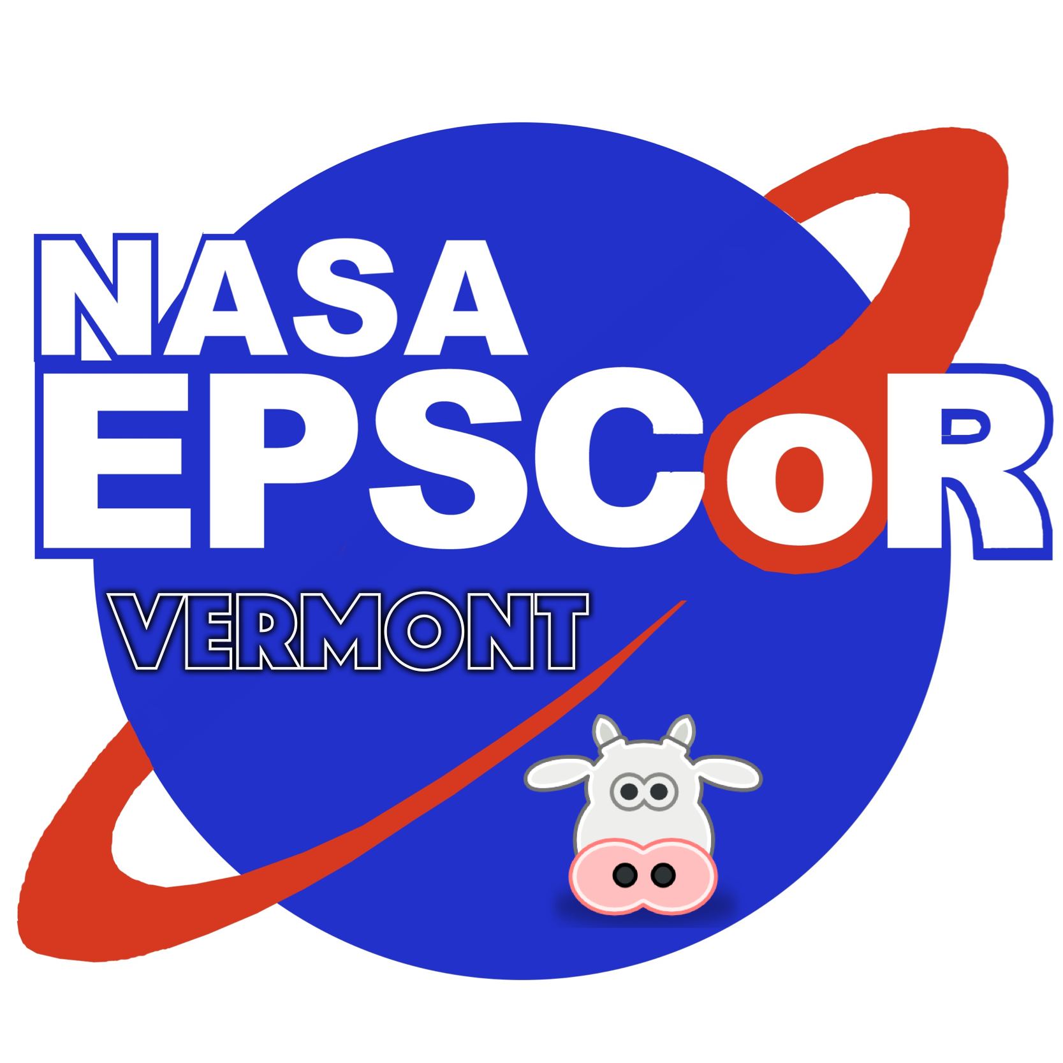

Vermont Space Grant and

Vermont NASA EPSCoR Program

2021 Faculty

Research Competition
Proposal Deadline: March 19, 2021 at 11:59 pm

Name and Title of Faculty Applicant: _______________________________________________

Project Title: __________________________________________________________________

Faculty Affiliation: _____________________________________________________________

Faculty E-mail: _____________________________ Phone number: _____________________

Grant Type (Check One):
Small-Scale Grant ___ VTSGC (June 2021 – May 2022)
Pilot-Grant ___ VTSGC (June 2021 – May 2022)
Small-Scale Grant ___ VT NASA EPSCoR (October 2021 – September 2022)

NASA Area(s) of Relevance: _____________________________________________

Signature:

Faculty Member: ______________________________________________________________ Print Sign Date

Checklist: COMPLETE APPLICATION DUE BY 11:59 p.m. on March 19, 2021:

UVM Faculty
- Cover Page ___
- Project narrative (limit of five pages for Small-Scale Grant, three pages for Pilot Grant, exclusive of references) ___
- A short section expliciity detailing NASA alignment (limit of one page) ____
- Letters/emails of support from NASA contacts or collaborators (mandatory for Small-Scale grant applications, strongly encouraged for Pilot grant applications) ___
- A detailed budget request with detailed justification and matching plan___
- If applicable, a signed letter of commitment from the appropriate institution or other official responsible for the source of the match. ___
- Two-page CVs for any faculty participant(s) or other key project participant(s) ___

Non-UVM Faculty (additional documentation needed)
In addition to the above list of documents needed, a non-UVM principal investigator will need to submit a subrecipient monitoring form. This document can be found at:
https://www.uvm.edu/sites/default/files/Sponsored-Project-Administration/subrecipientcommitmentform.pdf

The complete application must be saved as a single PDF file and emailed to the VT Space Grant Office to Ms. Debra Fraser (dfraser1@uvm.edu) with CC to Director Bernard Cole (SG.Director@uvm.edu).

Please choose your first preference; however, your actual start date might change depending on funding availability and funding sources.

